**How to Install Anaconda?**

**Step 1**: Type “anaconda download” in your browser

**Step 2**: Click “Download” or proceed to Step 3 for more options.

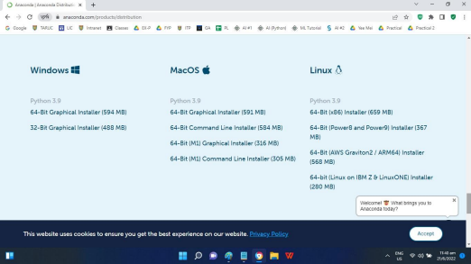**Step 3**: Click on the right option of the installer.

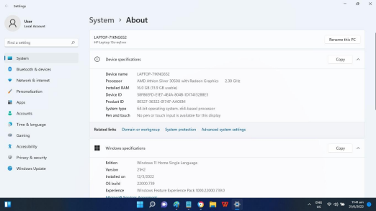**Step 4**: Find out more about your “System Type”.

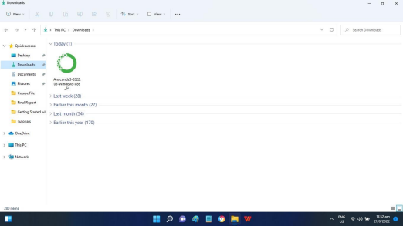**Step 5**: Double click the downloaded installer

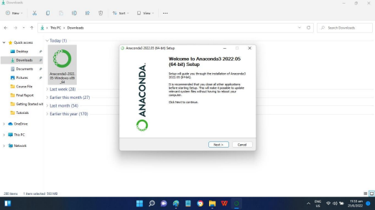**Step 6**: Click “Next” to proceed to the next step.

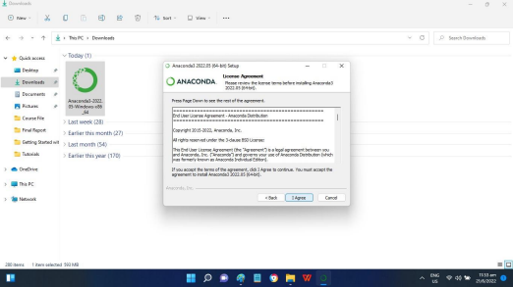**Step 7**: Click “I Agree” to proceed to the next step.

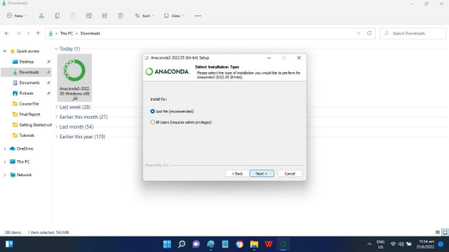**Step 8**: Select “Just Me” and click “Next” to proceed to the next step.

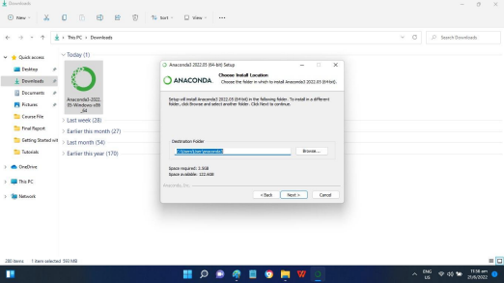**Step 9**: Click “Next” to proceed to the next step.

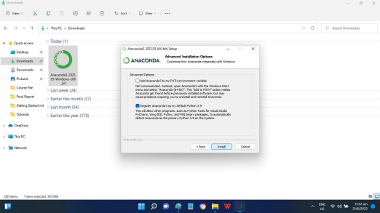**Step 10**: Click “Install” to proceed to the next step.

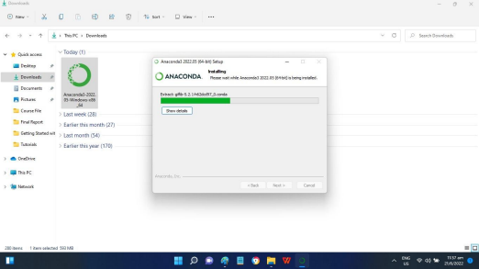**Step 11**: Installation is progressing.

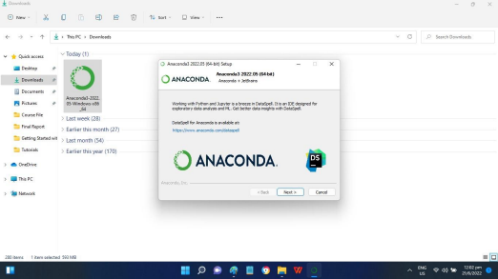**Step 12**: Installation is complete, click “Next” to proceed to the next step.

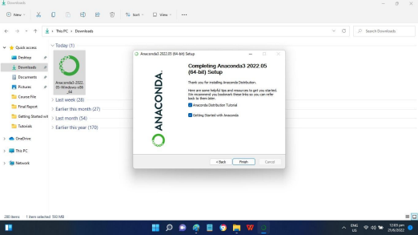**Step 13**: Click “Next” to proceed to the next step.

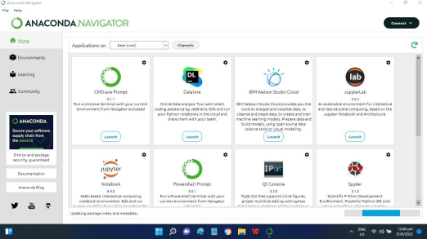**Step 14**: The program is started automatically, wait for the update to be completed.

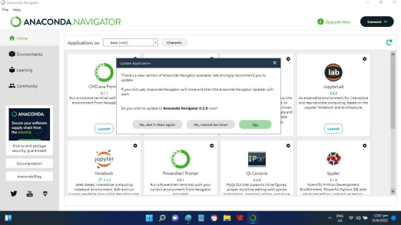**Step 15**: The program prompts for update, click “Yes” to proceed to the next step.

**Step 16**: Click “Update Now” to proceed to the next step.

**Step 17**: Wait for the update to be completed.

**Step 20**: Click “Launch Navigator” to proceed to the next step.

**Step 21**: Wait for the update to be completed.